Hello, My name is Rajan and I’m writing this workshop/bootcamp to make you zero to hero in Angular in easiest way possible , I would like to extend my arms to help many in Angular, You only have to spend 15 to 20 mins over here in reading and do support my work with feedbacks, Thank you.

Lets start!!!!

Chapter 1.

Introduction

Node js- server side scripting(execute on server side)

Angular/react- Client side scripting(execute on client side)

8 sec avg time of angular or clientside renders

Java script(jquery) is being used for client side

google team realized to create a fastest library so created angularjs/angular 1

JS doesn't support oop concept so created extended angularjs but its code was heavy

so created a framework instead of library in angular 2(used typescipt in it)

Typescript is superset of JavaScript

Library vs Framework

Library is file who have collection of functions and methods

Framework is system who have abilities to create own application using functions

ex- Framework is Indian constitution we have to behave according to it as citizens

Only client side framework have everything like services, directive

What is DOM(Document Object Module)

When we render page and go to inspect and see generated HTML Code then it is called as DOM

How to see DOM

Go in web site RIGHT CLICK( find inspect)

Building Blocks of Angular(Don't worry I will discuss this further)

1.Module(atleast one module- default module/root module is 'app.module.ts')

2.Components(at least1 and default is 'app.component.ts',component will have 4 component html,css,ts and testing file)

3.Templates

4.Metadata

5.Data binding(communication between view and component, 2 types property and event binding)

6.Directive(Killer feature- We can make things dynamic, changes dom structure,3 types component,structural,attributes)

7.Services(service is function which does a specific task for reusability)

8.Dependency Injection(creating object of service in component and using it is called)

What is decorator

any word having below data

prefix @

postfix({ })

app.module.ts

ex- @ngModule({

declaration:[ componentname ],

imports:[ Modulename ],

providers:[ serviceName ],

bootstrap[ appcomponent]

})

bootstrapModule?

It is used for deciding sequence of execution in Angular

Workflow of angular application ->RUN->main.ts->appModule

1. Run

2. main.ts

in main.ts it will find bootstrapModule and name in it here it is AppModule so it will load appmodule there also it will find bootstrap

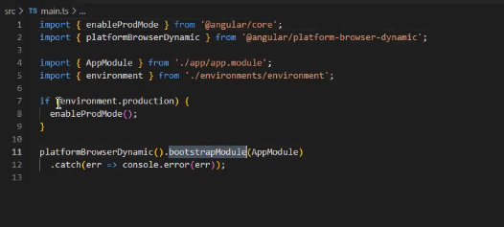

3. AppModule

In appmodule also it will find a bootstrap and now it will go in ts file of AppComponent so it will check its template url and load its html file now

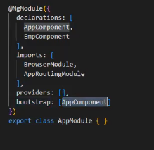

4. Selector and template url

So Finally in selector will take it to index.html so it will render on index.html

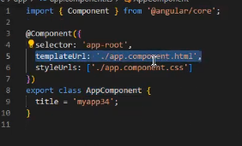

This is why we call it as Single Page Application

App.component.html will be loaded with the help of selector.

Chapter 2.

Basic Architecture & history

RxJs Library is heart of Angular now a days it is inbuild library

Angular(2-8) compiler- View Engine

Angular (9-14)compiler- Ivy rendering engine- code level checking and removes unused code

1.Angularjs/Angular 1 & Angular 2

Discussed in last class

2.Angular 3(Never released)

Angular 2 had router libraries which were higher so never released angular 3

3.Angular 4

Angular size reduced to 60%, encoding decoding increased, \*ngif/else added,email validation

4. Angular 5

HTTPClient API added server communication made easy , Multiple Export Aliases-easy for migration,Pipes for Number, date and currency(upper case lower case directly in html), Lamda support

5. Angular 6

‘ng update’ added for angular 2 to angular 6, bootstrap changed

6. Angular 7,8

‘update.angular.io’- again for migration, multiple validator, dynamic import, lazy loading, bye bye http

7. Angular 9

Ivy rendering engine compiler

Angular Semantic Versioning Example what is 13.1.2 angular, release frequency

1.Major- Entire version changed so change project-13

2.Minor- back word will be used-1

3.Patch- bugs fixed-2

So 5.0.0 to 5.2.9 can be changed but 5.9.9 to 6.0.0 not possible because version is changed

Beta version

Not tested version by team angular which we cannot use it in production

That’s it for today, Tomorrow lets do next two chapters